11th Grade CONFIRMATION
Sacred Heart Parish

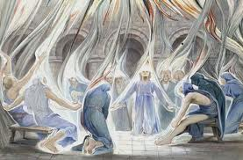
COME HOLY SPIRIT….

Coordinator of Confirmation Preparation
Scott Frieler
sfrieler@sacredheartsaukrapids.org
320-251-8115 ext. 117
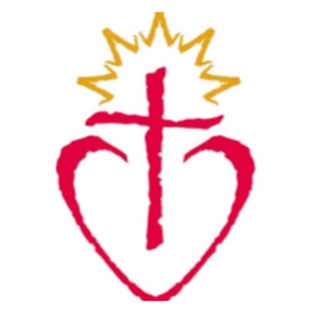
11th Grade CONFIRMATION PROGRAM 2022-23

************************************************
Program Goals:

To empower young people to live as disciples of Jesus Christ in our world today.

To draw people to responsible participation in the life, mission, and work of the Catholic Faith community.

To foster the total personal and spiritual growth of each young person.
************************************************

The Diocese requires that we collect a Baptismal Certificate from each Confirmation Candidate for parish record keeping. Students who were not Baptized at Sacred Heart need to provide the parish with a copy of their Baptismal Certificate. If you do not have a copy at home, you can call the parish where your Candidate was Baptized and ask them to scan, fax or mail a copy to Sacred Heart. (Info on last page) Please do this as soon as possible.

Confirmation 2022-23

Discipleship Training Sessions (DTS)
Confirmation Preparation will be offered to any student in grades 11th grade or older (with students in upper grades getting priority).

- DTS Sessions - 11 Sessions from September – December at Sacred Heart
- Sessions are on Sunday from 7:00 – 8:30 PM

DTS are not academic classes, but Discipleship training which includes: experiential learning events, small group discussion, and exercises developed to help the student reflect on their own goals regarding their faith, deepen their prayer life and develop their own unique spirituality.

Expectation of the Candidate Preparing for Confirmation
- Our expectation is that the candidate will be appropriately prepared and involved in a religious education program prior to entering our program. If your child has not been enrolled in another program, additional work may need to be completed before they enter the Confirmation program.

- To participate in spring of 2023 Confirmation Celebration, all classes and individual assignments must be completed and turned in to Scott Frieler Friday, April 7th, 2023.

- If the student is not able to complete the requirements before that date, all work completed can be “banked” and participate in the next parish Confirmation Ceremony when work is completed.

- By offering the Candidate the ability to work toward Confirmation as they feel compelled to do so, we hope to offer them more flexibility with their schedules and the freedom to choose when they feel ready to receive the Sacrament of Confirmation as opposed to being forced through the system at a specific grade level.

- The Confirmation process is an opportunity for spiritual growth that will require the Candidate’s attention and devotion. We believe that if someone is ready to be Confirmed this attention and devotion will be evident in their actions, and the preparation with be completed well within the deadlines.

Steps in 11th Grade Confirmation Preparation:

Step I: Introductory meeting/Orientation Session.
- Complete the Sacramental Form
- Students Baptized at Sacred Heart can indicate that on the Sacramental Form. If not baptized at Sacred Heart, The parish will need to get a Baptismal Certificate from the parish where the Candidate was baptized as soon as possible. The easiest way to do this is to have the parish fax, scan, or mail a copy to St. Josephs. Information is located on the back page.

Step III. Attend Commitment Sunday Weekend October 8th & 9th.
All Candidates are expected to be at one of the weekend Masses at Sacred Heart. Mass times are Saturday- 5:00 PM, Sunday 9:00 AM

Step IV. Attend Liturgy Training Event on Wednesday, February 15th at 7:00 PM at Sacred Heart OR complete 3 Liturgy sheets.

Step V. Complete 6 Approved Service Opportunities- Service is an opportunity to learn about the Gifts given to each of us by God as well as a requirement for Christian Discipleship. Candidates will be asked to complete a minimum of 6 approved service-learning opportunities with 3 of the opportunities occurring at Sacred Heart or in the ACC.
Check the website for opportunities to serve at Sacred Heart under the Confirmation Tab. Once a service opportunity is completed, the candidate will complete a google form for the project at the following link. https://docs.google.com/forms/d/e/1FAIpQLScj6xAdeWZieb21td_d8YhBQ6bllMl83brC5ckwgFzPGmecgQ/viewform?usp=sf_link

Step VI. Confirmation Mentor Journal: Candidate will meet with their mentor/sponsor regularly to complete the Journal. (The Journal can be found on the website.)

Step VII. 11 Discipleship Training session. Candidate will attend DTS Session from September – December. If you miss a class due to illness, you will be assigned a makeup lesson to be done with your mento/parent. Unless there are special circumstances, any student who misses more than 2 classes during the session, will be required to wait until the next session to start again and be confirmed at the next parish celebration of the Sacrament.

Step VIII. Candidate will Complete Confirmation Learning Centers with a parent. The dates of the Learning Centers are Sunday, February 5^{th,} and February 12th from 11:00 – 3:00 PM in St. Stephen. More information to come after January.

Step IX. Retreat experience. Candidates can sign up to attend a retreat Saturday, October 15th, Saturday, November 19th or Saturday, January 7th at Sacred Heart from 10:00 AM – 5:00PM. YOU MUST ATTEND A CONFIRMATION RETREAT. FAILING TO DO SO COULD EXCLUDE YOU FROM RECEIVING THE SACRAMENT IN THE SPRING.

Step X. Candidates will get all documentation required to Scott by April 7, 2023.

Step XI. Confirmation candidate will complete a Dialogue with the clergy or ministry staff from our parishes. (Dialogues will be schedule at week or two before the Confirmation Date. This is not a test, but a chance for clergy to meet you and discuss what gifts you bring to the community)

Step XI. Candidate will attend 2 additional – Confirmation Preparation Meetings before Confirmation occurs to: plan the liturgy, write a letter to the Bishop. Every effort will be made to get these dates to you as soon as the date for Confirmation 2021 is given to us by the Bishop. (These class times and all other relevant messages will be posted online and through the app)

Step XII. Attend the Confirmation Ceremony.

Where can I find updates with the 11th Grade Confirmation Program?

1. Watch your Emails. (Please check your email at least once a week)
- Emails will be the primary way to communicate events and opportunities.

2. Check the Sacred Heart Parish Website
- Go to the Sacraments tab and click on Confirmation.

CONTACT INFORMATION

Confirmation Coordinator: Scott Frieler:
Email Address- sfrieler@sacredheartsaukrapdis.org
Address: 2875 10th Ave NE, Sauk Rapids MN 56379
Phone: 320-2518115 ext. 117
Text: 320-492-8604
Our web page: https://www.sacredheartsaukrapids.org/

ACC Pastors: Fr. Tom Knoblach & Fr. Ron Wyrens

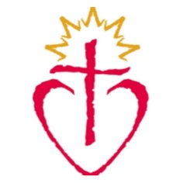

11th Grade Candidate Checklist for your fridge:

- Complete 6 Approved Service Opportunities. Parent or Mentor are encouraged to participate as able. (3 Opportunities should be within the Parish or ACC)
* *
* *
* *

- 10 Discipleship Training Sessions:
Attend 2 final all-group sessions:

- Attend Liturgy Training Event (February 15th @ 7:00 PM) or complete 3 Liturgy Sheets

- Attend a Confirmation Retreat

- Attend Commitment Weekend Mass at Sacred Heart the Weekend of October 1st & 2nd

- Complete a Journal with your Mentor.

- Attend the Learning Sessions @ St. Stephen either Sunday Feb 5th or Sunday Feb 12

- Students will meet for a Confirmation Dialogue in the weeks preceding Confirmation with either the clergy or staff.

All documents can be dropped off at the Sacred Heart Parish Office or Emailed to Scott.

